Ontario Gateway: Synopsis

Comparison of Insurance Plans

Note: All numbers will vary between runs of the simulation. The values reported here were obtained from a run with 100,000 trials.

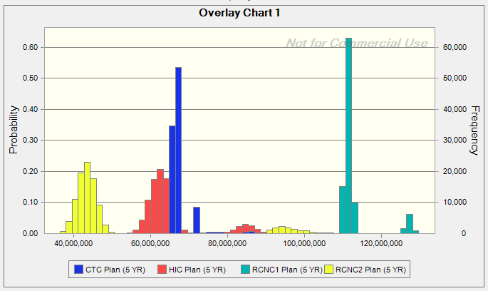

Year 1 Cost 5-Year Cost ($M)
Prob > $37M Mean Std. Dev.
RCNC1 0.03% 113.6 6.3
RCNC2 2.43% 49.8 18.3
CTC 0.03% 67.5 3.9
HIC 0.00% 65.2 8.1

Notes:
- First year cost exceeds $37M for RCNC2 if there is a crash in the first year. First year cost exceeds $37M for RCNC1 and CTC if there are two or more crashes in the first year. First year cost cannot exceed $37M for HIC.
- RCNC1 can be eliminated. The 5-year cost is very high compared to the other plans, and there is no advantage over CTC and HIC in terms of the probability of cost exceeding $37M in the first year.
- The remaining 3 plans all have pros and cons. RCNC2 has the lowest expected 5-year cost, but the variation in cost is the highest and the chance of the first-year cost exceeding $37M is much higher than for CTC or HIC. CTC has the lowest variation in 5-year cost, but there is about an 85% chance that the cost for HIC will be lower (see chart below), and the chance that the first-year cost exceeds $37M while very small is not zero. HIC has a lower expected 5-year cost than CTC and a zero probability that the first-year cost exceeds $37M, but the variation in 5-year cost is higher than for CTC.

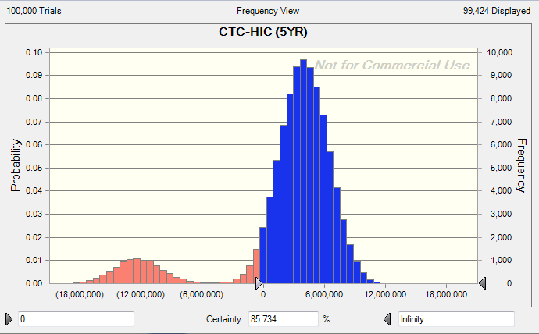

Effect of Reducing Crash Probability

Reducing the crash probability by 25% has a small effect on the mean and standard deviation of 5-year cost for all 4 plans. The probability of the first-year cost exceeding $37M is reduced for RCNC1, RCNC2 and CTC but remains much higher for RCNC2 than for the other two. The comparisons between the different plans are similar to the base case above.

Effect of Discounting

Discounting, if used, must be applied to all cash flows after the first year (not just the possible rebates at the end of the 5-year period) and requires some care to implement correctly. Discounting has no effect on the chance of first-year costs exceeding $37M. Using a 6% discount rate, the distributions of discounted 5-year costs are qualitatively similar to the base case (see chart below), as are the comparisons between the different plans.

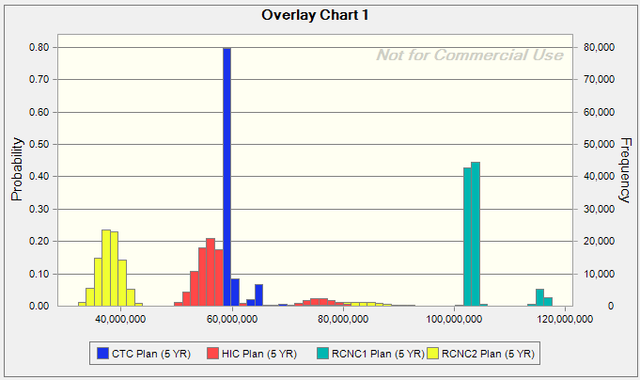

Recommendation

The RCNC1 plan can be eliminated from consideration. The RCNC2 plan is unattractive compared to CTC and HIC due to the higher variation in 5-year cost and much higher chance of first-year cost exceeding the critical $37M threshold. HIC compares favorably to CTC on the basis of both first-year and 5-year costs and appears to be a very good option, but the CTC plan is the best in terms of minimizing the uncertainty in 5-year cost.

